Mobile Game (title W.I.P)

Game Concept
The game would be a mobile carnival minigame collection, I’m inspired by Carnival Games on the DS for this as it made excellent use of the DS touchscreen and I feel that the gameplay loop would work very well on mobile devices. It would have two carnival minigames which the player could access from the main menu of the game. Each of the minigames would use touchscreen controls, allowing the player to swipe or tap the screen to control them. The overall aim of this would be to attempt to recreate the fun and experience of traditional carnival games in a way where people can play them on the go very conveniently.

Target Audience
The target audience is primarily casual players, people of all ages could understand this game due to its simple control scheme, which makes it perfect for mobile devices as people of all ages have one. It will be accessible to players of different capabilities when it comes to gaming, with easy objectives and simple controls. The minigames will also allow people who don’t want to commit to a long game to play the game, as they will be short, making it perfect for bus rides or if you’re waiting for something.

Target Mobile Platform
The target platform would be android as it is the kind of phone that I have, making it much easier for me to program and test for it as it is much easier to push a game to an android device too. The interface itself will be designed to work on plenty of phone models, big or small, it will have clear text and graphics.

Core Gameplay Loop
The core gameplay loop would be this:
Player starts game – choice between one of two carnival games – select minigame 1 or 2 – results screen – return to menu

Game Orientation
The game is planned for use on portrait mode specifically due to it’s much more convenient orientation as many people who play games on their phone prefer to play portrait as it’s more comfortable to hold the phone that way as opposed to landscape.

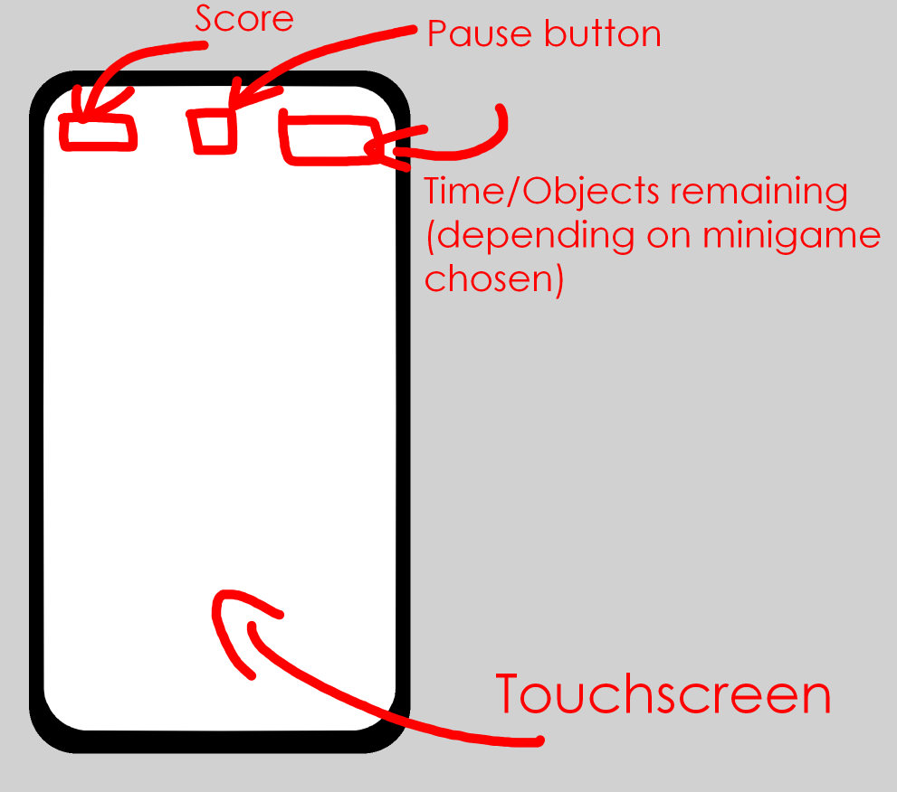
Wireframes:


